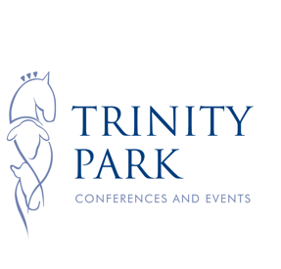

TRINITY PARK CHRISTMAS PARTY BOOKING FORM 2017

Please fill in all of the boxes below in order for us to accept your booking.

YOUR NAME:
COMPANY/GROUP NAME (as you want it to appear on our table plan):
CORRESPONDANCE ADDRESS:
POST CODE:
TEL: MOBILE:
EMAIL ADDRESS:
SECONDARY CONTACT NAME:
SECODNARY CONTACT TEL:
SECONDARY CONTACT EMAIL:

PREFERRED DATE:
NUMBERS:
Note our average table size is for 10 guests unless specified. If less than 10 guests in one party you may be required to join another small group. Banquet tables may be used on prime nights for larger parties of 14-20 guests.

EARLY BIRD
£58.50 per person including 2 bottles of prosecco per table of 10 (please note if numbers are less or more we will work out the appropriate number of bottles for your party).

After this date our package price remains at £58.50 per person.

DEPOSIT
£15.00 per person required to secure your reservation. Please note all deposits are non-refundable and cannot be used against any other service or product.

To take advantage of the Early Bird Offer of £58.50 per person deposits must be received by Friday 31st March 2017.

TERMS AND CONDITIONS
Full terms and conditions will be sent with the deposit invoice.
To reserve your place/s at the Trinity Park Christmas Parties 2017 just email this booking sheet to sarah.jay@trinityparkevents.co.uk or call the events team on 01473 707119

